**Sales Performance Analysis**

**Objective:**

To build a dashboard that will present monthly sales performance by product segment and product category to help client identifying the segments and categories that have met or exceeded their sales targets, as well as those that have not met their sales targets.

**Data set names:**

Sample - Superstore and Sales_Target

**Tableau Public Link:**

<https://public.tableau.com/views/SalesPerformanceAnalysis_15941287732950/Dashboard1?:language=en&:display_count=y&publish=yes&:origin=viz_share_link>

**Insights:**

* Created Bullet chart with Category and Segment dimensions and Sales measures from Sample - Superstore dataset.
* Blended the data with Sample - Superstore and Sales_Target dataset.
* Coloured the chart to identify the Categories and segments that are above and below the target using parameter.
* Added Filter for Year Order data.
* Created Dashboard with the bullet sheet.

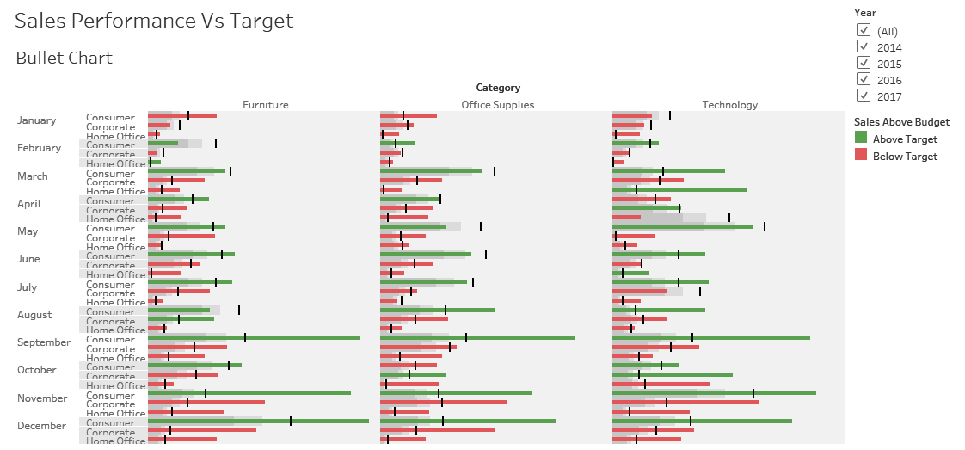**Screenshot of the output:**